

**American College of Technology (ACT)**

**Department of Computer Science**

Postgraduate project proposal

**Title:**

Ethiopian Stock Market Simulation Platform for Learning, Regulatory Compliance and Market Preparedness

**Name ID**

1. **Biniyam Kefelegn 010/2022**
2. **Tesfaye Fekadu 074/2022**
3. **Sebele Fekede**

**04-12-2024**

Contents

Chapter 1: Introduction 1

1.1. Background of the project 1

1.2. Statement of the Problem 1

1.3. Objectives of the project 2

1.3.1. General Objective: 2

1.3.2. Specific Objectives: 2

1.4. Scope of the project 2

1.5. Limitation of the project 3

1.6. System Development Methodology 3

1.6.1. System Development Approach 3

1.6.2. System Development Tools 5

1.7. Significance of the Project 5

1.8. Beneficiaries of the Project 6

1.9. Feasibility Study 7

1.9.1. Technical Feasibility 7

1.9.2. Economic Feasibility 8

1.9.3. Operational Feasibility 9

1.10. Project schedule 9

1.11. Project Budget 10

Total Budget: 200,000 ETB 10

**Chapter two** 11

**Requirement Analysis** 11

# Chapter 1: Introduction

## Background of the project

The Ethiopian Capital Market Authority (ECMA) is establishing a formal securities exchange to foster economic growth and provide a platform for raising capital in Ethiopia. The success of this initiative depends heavily on the preparedness and understanding of potential investors, brokers, regulators, and the general public about stock market dynamics. Ethiopia's financial market is still in its early stages, and there is a significant lack of experience among these market participants. Without a good understanding of how a stock market works, stakeholders may struggle to manage the complexities of securities trading, market analysis, and regulatory compliance.

This proposal aims to develop an interactive simulation platform that mimics the functions of a real stock exchange. The platform will provide a practical learning environment where users can simulate trading activities, understand market behavior, and test regulatory policies in a risk-free setting. This approach helps bridge the knowledge gap and enhances market readiness.

## Statement of the Problem

Ethiopia's new financial market faces challenges in developing skilled and knowledgeable participants. Due to a lack of practical experience, investors, brokers, and regulators may not be well-prepared to handle real-life situations related to trading, market analysis, and regulatory oversight. The absence of a structured educational tool makes it difficult for stakeholders to understand key market operations and comply with regulatory standards.

There is a need for an interactive simulation tool that provides practical experience in stock market trading, market analysis, and regulatory compliance, following the guidelines set by the ECMA.

## Objectives of the project

### General Objective:

To develop an easy-to-use stock market simulation platform that prepares Ethiopian investors, brokers, and regulators for the upcoming Ethiopian stock market.

### Specific Objectives:

1. To design a robust platform that allows users to register as Traders and Listed Company Administrators and engage in realistic stock market simulations tailored to their roles.
2. To build an advanced trading engine that supports various order types (e.g., market orders, limit orders), performs real-time order matching using price-time priority algorithms, and notifies users upon successful trade execution.
3. To implement a comprehensive regulatory module that enables regulators to monitor market activities, enforce compliance, and assess the impact of regulatory policies in a controlled environment.
4. To provide data analytics and visualization tools that deliver real-time and historical market insights, empowering users to analyze trends, simulate strategies, and make informed decisions..

## Scope of the project

The platform will focus on simulating key stock market functions, such as trading, order matching, price discovery, regulatory compliance, and data services. It will serve different user roles like traders, brokers, market makers, exchange operators, and regulators. The platform will not handle real financial transactions but will provide a safe environment for learning and practice.

## Limitation of the project

* The platform is designed for learning and simulation and may not cover all the details of a real stock market due to the broad and complex rules in the directives.
* The Risk Management Tools and Educational and Training Features may not be fully developed in the initial version due to time constraints but will be considered for future updates.
* Due to the complexity of compliance and market surveillance, some advanced features related to compliance and regulatory testing may be simplified or excluded in this version of the platform.
* Regular updates will be needed to keep up with changes in ECMA regulations and market dynamics.

## System Development Methodology

### System Development Approach

The Ethiopian Stock Market Simulation Platform will adopt the **Agile software development methodology**. This approach enables iterative development, continuous feedback, and adaptability to evolving requirements. Key features of the Agile approach include collaborative efforts between developers and stakeholders, flexibility in responding to changes, and a focus on delivering a functional system in incremental phases.

The development process will be divided into the following phases:

1. **Requirement Analysis and Design**

* Collaborate with stakeholders, including the Ethiopian Capital Market Authority (ECMA), investors, and brokers, to gather detailed system requirements.
* Reference ECMA's resources, directives, and manuals to ensure compliance with regulatory frameworks.
* Design the platform architecture, user interface, and core modules such as the trading engine, regulatory compliance features, and data analytics tools.

1. **Development**

* Develop core modules, including:
* **User Management**: Handle different user roles and permissions for investors, brokers, market makers, and ECMA staff.
* **Trading Engine**: Simulate buy/sell orders, order matching, and portfolio management.
* **Clearing and Settlement System**: Ensure accurate transfer of securities and manage cash settlements.
* Integrate **market surveillance and compliance tools** to monitor activities, detect market manipulation, and enforce ECMA trading rules.

1. **Testing and Quality Assurance**

* Conduct extensive testing, including unit testing, integration testing, and user acceptance testing (UAT).
* Simulate various market conditions, such as high volatility, to ensure robustness and reliability.

1. **Deployment and Training**

* Deploy the platform on a scalable cloud environment for easy access and future expansion.
* Provide training sessions for ECMA staff, investors, brokers, and market makers to familiarize them with platform features and functionalities.

### System Development Tools

To efficiently develop and deploy the Ethiopian Stock Market Simulation Platform, the following tools and technologies will be utilized:

* **Development Frameworks**:
  + Backend: Django for handling server-side logic and APIs.
  + Frontend: Angular for building a responsive and interactive user interface.
* **Programming Languages**:
  + Python for efficient and scalable development.
* **Database Management**:
  + PostgreSQL for structured data storage.
* **Version Control and Collaboration**:
* Git for source code management.
* GitHub or GitLab for team collaboration and code review.

These tools and methodologies will ensure the development of a high-quality, compliant, and scalable stock market simulation platform.

## Significance of the Project

This project is crucial for Ethiopia's capital market development as it provides a practical learning tool for future market participants. By simulating real market conditions, the platform will help users gain confidence, understand trading mechanisms, develop regulatory compliance skills, and prepare for the real Ethiopian stock exchange. It will also serve as a useful tool for ECMA to test regulatory policies in a controlled environment.

## Beneficiaries of the Project

The Ethiopian Stock Market Simulation Platform is designed to address the knowledge and skill gaps among participants in Ethiopia's emerging financial market. The beneficiaries of the project include the following:

**Ethiopian Capital Market Authority (ECMA)**

* + Gain a practical tool to test and refine regulatory frameworks in a controlled simulation environment.
  + Monitor and enforce market compliance through the platform's regulatory modules.
  + Train staff on market oversight and surveillance, enhancing their readiness for real-world market operations.

**Investors**

* + Learn the basics of stock trading, portfolio management, and market analysis in a risk-free environment.
  + Gain confidence and practical experience to actively participate in the real Ethiopian stock market.
  + Understand the implications of regulatory policies and market dynamics on investment decisions.

**Brokers**

* + Develop practical skills in managing client accounts, executing trades, and navigating trading platforms.
  + Understand order types, order matching, and clearing processes.
  + Prepare for compliance with ECMA regulations and policies.

**Market Makers**

* + Simulate price stabilization strategies and liquidity provision in the market.
  + Learn to manage risks and ensure smooth market operations during high volatility.

**Exchange Operators**

* + Gain experience in managing the trading engine, clearing and settlement systems, and ensuring market integrity.
  + Test market mechanisms and infrastructure in a simulated environment before the live launch of the Ethiopian stock market.

**Regulators**

* + Learn to detect and address potential market manipulation and other compliance issues.
  + Evaluate the impact of new regulatory policies on market behavior without real-world consequences.

**Students and Academics**

* + Use the platform as a learning tool for understanding stock market mechanisms and regulatory systems.
  + Conduct research on market behavior and develop innovative strategies or policies.

**General Public**

* + Increase awareness and understanding of how a stock market operates, promoting broader participation in the financial market.
  + Build trust and confidence in the upcoming Ethiopian stock exchange by offering transparency and education.

## Feasibility Study

The feasibility study evaluates the Ethiopian Stock Market Simulation Platform project to determine its viability in terms of technical, economic, operational, legal, and scheduling aspects.

### ****Technical Feasibility****

This aspect assesses whether the required technology, tools, and expertise are available to develop and implement the platform.

* **Platform Design and Development**
  + Backend: Using Django for server-side logic ensures scalability and reliability.
  + Frontend: Angular provides a responsive and interactive user experience.
  + Database: PostgreSQL offers robust data management capabilities.
* **Technical Expertise**
  + Skilled developers with experience in Python, Django, Angular, and PostgreSQL are available.
  + Access to development tools such as Git and GitHub/GitLab ensures smooth collaboration.
* **Scalability and Future Upgrades**
  + Modular architecture supports future enhancements, such as adding risk management tools or advanced compliance features.

### ****Economic Feasibility****

This aspect evaluates the financial viability of the project, including cost analysis and expected benefits.

* **Cost Analysis**
  + **Development Costs:** Includes salaries for developers, designers, and project managers.
  + **Infrastructure Costs:** Cloud hosting services and database management tools.
  + **Maintenance Costs:** Regular updates and system monitoring.
  + **Training Costs:** User training for ECMA staff, brokers, and investors.
* **Expected Benefits**
  + Reducing the cost of errors in the real market by providing a risk-free training platform.
  + Increasing investor participation and market liquidity through better awareness.
  + Supporting ECMA in refining policies, minimizing regulatory implementation risks.

### ****Operational Feasibility****

This aspect evaluates whether the project aligns with the needs of its stakeholders and can be effectively implemented.

* **Stakeholder Alignment**
  + ECMA: The platform provides a testing ground for regulatory policies.
  + Investors and Brokers: Enhances knowledge and confidence, ensuring smooth market participation.
  + Market Makers: Prepares participants for real-life market operations.
* **Ease of Use**
  + The platform’s user-friendly interface ensures accessibility for all participants.
  + Training sessions help stakeholders effectively utilize the system.

## Project schedule

The Ethiopian Stock Market Simulation Platform will be completed in approximately 4 months, divided into four phases with specific milestones and activities.

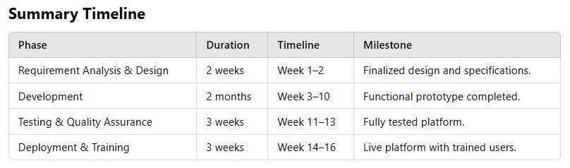

This schedule ensures timely delivery while allowing for iterative development and stakeholder engagement.

## Project Budget

The total budget for the Ethiopian Stock Market Simulation Platform is set at **200,000 ETB**. Below is a breakdown of the estimated expenses across different cost categories.

**1. Personnel Costs**

* **Developers** (2 @ 20,000 ETB/month for 4 months): 160,000 ETB
* **UI/UX Designer** (1 @ 10,000 ETB/month for 2 months): 20,000 ETB
* **Tester** (1 @ 5,000 ETB/month for 1.5 months): 7,500 ETB

**Subtotal:** 187,500 ETB

**2. Infrastructure Costs**

* **Cloud Hosting Services:** 6,000 ETB
* **Development Tools and Software Licenses:** 2,000 ETB

**Subtotal:** 8,000 ETB

**3. Training and Documentation**

* **Training Sessions for Stakeholders:** 2,500 ETB
* **User Manuals and Documentation:** 1,500 ETB

**Subtotal:** 4,000 ETB

**4. Miscellaneous Expenses**

* **Contingency Funds (unexpected expenses):** 500 ETB

**Subtotal:** 500 ETB

### ****Total Budget: 200,000 ETB****

# Chapter 2: Requirement Analysis

## Current System Description

Ethiopia currently lacks both a formal stock market and a simulation platform to facilitate understanding and practice of stock market operations. As such, no existing system in Ethiopia performs the functionalities that this project aims to address.

### Major function of the current system

The absence of an operational stock market system means that:

* No mechanisms exist for simulating trading activities or analyzing market dynamics.
* Regulatory bodies lack tools to test compliance frameworks and policies.
* Educational resources and platforms for stakeholders to understand stock markets are non-existent.

### Problem of Existing System

#### 2.1.2 Problems of the Existing System

The lack of a stock market and simulation platform results in several challenges:

* **Knowledge Gap**: Stakeholders, including potential traders, companies and regulators, lack practical exposure to stock market operations, trading strategies, and compliance requirements.
* **No Practical Training Tools**: There is no simulated environment where users can practice trading, market analysis, or regulatory testing in a risk-free setting.
* **Regulatory Challenges**: The Ethiopian Capital Markets Authority (ECMA) has no platform to test regulatory policies or simulate the impact of those policies.
* **Limited Public Awareness**: The public has minimal access to tools or educational resources to understand stock markets, limiting their readiness for a functional exchange in the future

## Requirement Gathering

### Requirement Gathering Methods

To build a simulation platform that addresses the challenges, the following methods were employed:

* **Observation**: Studying simulation platforms in established markets to identify industry best practices, design considerations, and feature sets.
* **Document Review**: Reviewing ECMA directives, legal documents, and regulatory frameworks to ensure alignment with Ethiopia's evolving capital market regulations.

### Business Rules

The platform must adhere to the following rules to meet the requirements:

* The system must strictly comply with ECMA’s regulatory frameworks to ensure credibility and usability.
* Only registered users (classified as traders, listed company admins and regulators) will have access to the platform’s specific functionalities based on their role.
* The trading engine must accurately simulate real-world trading mechanisms, including order types (e.g., market, limit orders) and execution processes.
* Market data provided on the platform must replicate real-world formats for effective training and analysis.

## Proposed System Description

### Overview

The proposed system is an Ethiopian Stock Market Simulation Platform, designed to mimic real-world trading activities, provide market analysis tools, and incorporate regulatory oversight features. This platform will serve as a comprehensive learning tool for stakeholders, including

* **Traders**:
* Designed for individual participants to learn effective trading strategies, enhance their portfolio management skills, and understand the intricacies of market operations.
* Traders can place buy/sell orders, track their portfolio, and receive notifications about their trades, simulating a complete trading experience.
* **Listed Company Administrators**:
* Enables representatives of listed companies to manage their company profiles, publish stocks, and declare dividends.
* They can also monitor their company's trading activity, ensuring a realistic simulation of administrative responsibilities in a stock market ecosystem.
* **Regulators**:
* Provides tools for simulating regulatory oversight, approving or rejecting trader and company registrations, monitoring trading activities, and managing compliance violations.
* Regulators can generate comprehensive reports, set market alerts, and test the effectiveness of regulatory policies in a controlled environment.

By providing a secure, virtual environment, the Ethiopian Stock Market Simulation Platform empowers stakeholders to gain practical experience, deepen their understanding of stock market dynamics, and contribute to the successful establishment and sustainability of Ethiopia’s upcoming stock exchange.

### Functional Requirements

* **User Registration and Role Management**
* Supports multiple user roles: **Traders**, **Listed Company Admins**, and **Regulators**.
* Role-based access control ensures secure, tailored access to features.
* **Trading Engine**
* **Order Placement**: Supports multiple order types (market, limit).
* **Order Matching**: Utilizes **Price-Time Priority Algorithm**, ensuring fair and efficient execution by prioritizing best price and order submission time.
* **Execution and Market Depth**: Simulates real-world trading with real-time order books, bid-ask spreads, and partial matching capabilities.
* **Portfolio Management**
* Allows traders to manage virtual portfolios, monitor performance, and track trading history.
* Provides performance analytics and risk assessment tools.
* **Regulatory Tools**
* Enables regulators to monitor compliance, enforce rules, and generate detailed reports.
* **Market Analytics**
* Offers real-time updates, historical market data, and visualization tools for trend analysis and decision-making.

### Nonfunctional Requirements

#### 2.3.3.1 Performance

The platform must provide a responsive and efficient user experience, handling trading simulations, regulatory operations, and administrative tasks with minimal latency and seamless interactions.

#### 2.3.3.2 Scalability

The system should support the addition of new features and the ability to scale to accommodate an increasing number of users and activities as the platform grows alongside Ethiopia's market readiness.

#### 2.3.3.3 Availability

The platform must remain highly accessible and reliable, ensuring continuous operation during the designated transaction periods set by the system's regulators. Outside these periods, the platform should remain available for non-transactional activities such as portfolio management, monitoring, and administrative tasks, with minimal downtime for maintenance.

#### 2.3.3.4 Reliability

The system must ensure the accuracy and consistency of all simulations, including trading, order matching, and compliance monitoring, to provide a realistic and dependable market environment.

#### 2.3.3.5 Maintainability

The platform’s codebase must be modular and well-documented to allow for straightforward updates, troubleshooting, and the integration of new functionalities as needed.

#### 2.3.3.6 Security

Robust security measures must be implemented, including secure authentication, role-based access control, and data encryption, to safeguard user data and trading activities.

#### 2.3.3.7 Environmental

The system will be hosted on optimized local infrastructure, aligning with resource availability and reducing environmental impact while maintaining operational efficiency and data control.

#### 2.3.3.8 Usability

The user interface must be designed for ease of use, providing clear navigation and accessible features tailored to the needs of traders, listed company administrators, and regulators.

#### 2.3.3.9 Interoperability

The platform should enable exporting data and reports in standard formats such as CSV, Excel, and PDF, supporting external analysis and regulatory compliance efforts.

This structured approach ensures the platform meets the diverse needs of its stakeholders while maintaining scalability, security, and sustainability.

# Chapter 3: System Model

3.1.1 Use Case Model

The Use Case Model provides a structured representation of the interactions between users (actors) and the system as well as the role of the trading engine as a sub-system. highlighting the key functionalities offered by the Ethiopian Stock Market Simulation Platform. It serves as the foundation for understanding system requirements and user roles.

3.1.1.1 Actor Identification

The platform supports the following primary actors:

* 1. **Trader**:

**Role**: The trader represents an individual participant in the simulation who interacts with the system to perform trading activities.

**Responsibilities**:

* Registers with the platform to gain access.
* Places buy or sell orders using the trading interface.
* Monitors order statuses, manages portfolios.
* Receives notifications about executed trades, and system updates.
  1. **Listed Company Admin:**

**Role**: Acts as a representative of a listed company managing stock-related activities.

**Responsibilities**:

* Registers the company and manages its profile.
* Publishes company stocks and declares dividends for shareholders.
* Monitors trading activities involving their listed stocks.
* Generates reports and manages stock visibility on the platform.
  1. **Regulator**:

**Role**: Represents the governing body overseeing the simulation to ensure compliance and regulatory adherence.

**Responsibilities**:

* Approves or rejects user registrations for traders and listed company admins.
* Monitors market activities for compliance and can suspend traders if necessary.
* Sets system working hours to regulate trading periods.
* Generates compliance and market reports to ensure transparency and fairness.
  1. **Trading Engine (Sub-System):**

**Role**: The trading engine operates as a core sub-system, automating critical trading functionalities.

**Responsibilities**:

* Matches buy and sell orders using a price-time priority algorithm.
* Executes trades in real-time, updating user portfolios and order statuses.
* Sends notifications to users upon successful trade execution.
* Logs all transactions for regulatory and auditing purposes.

3.1.2 Use Case Diagram

The use case diagram visually represents the interactions between actors (Trader, Listed Company Admin, Regulator) and their respective functionalities. It also highlights the role of the trading engine as a sub-system for automating trading-related processes. Refer to the provided diagram for detailed visualization.

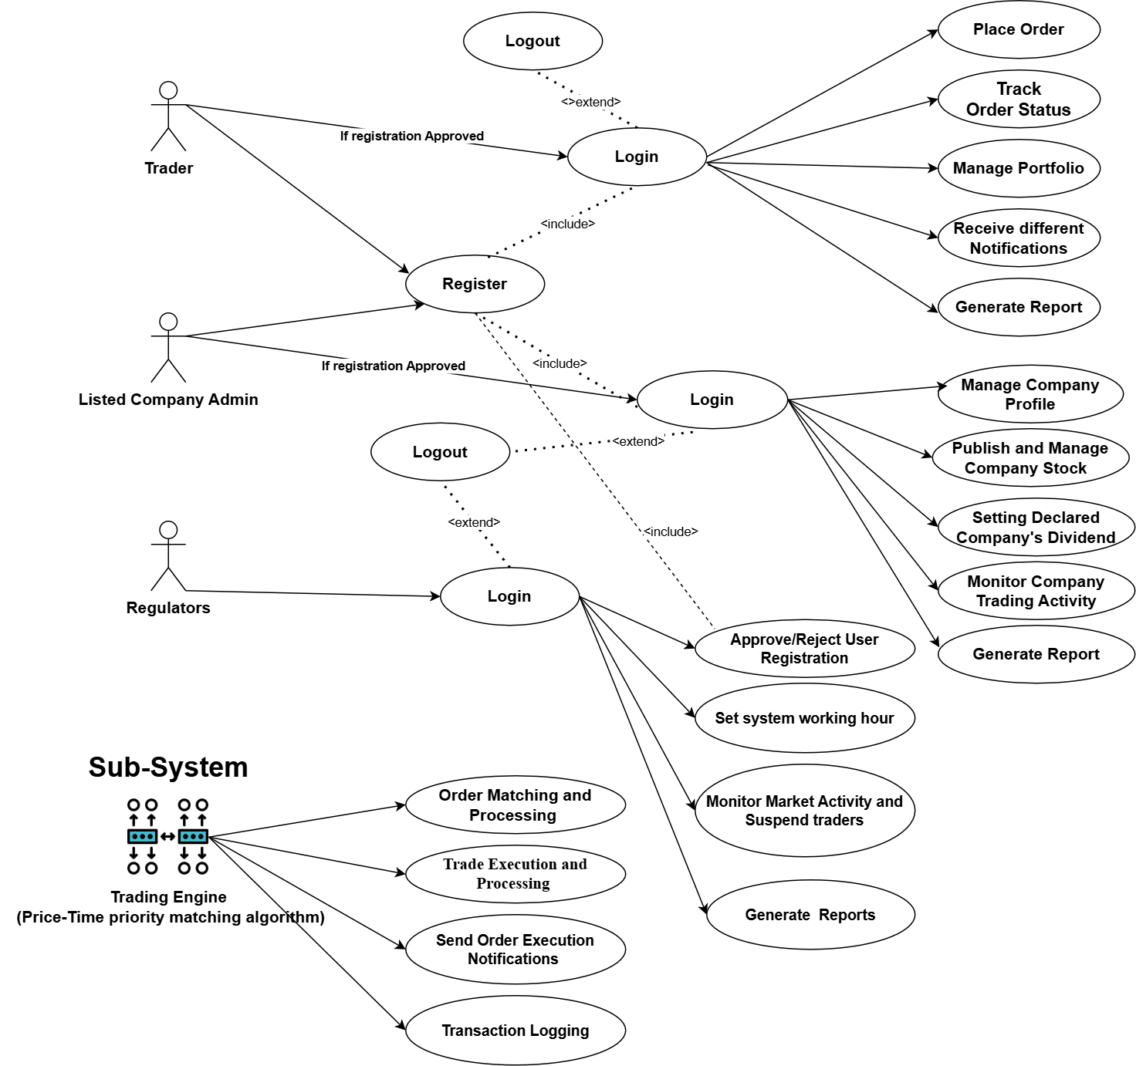

**Use Case: Trader Operations**

|  |  |
| --- | --- |
| Actors | **Trader** |
| Description | This use case allows traders to register, place orders, manage portfolios, track orders, and receiving system notifications. |
| Preconditions | The trader must have a KYC approved and active account. |
| Post conditions | User can Login, place orders, manage portfolios, receive system notifications and can receive dividend for their owned stocks |
| Events | * **Register User**: Traders register by providing required details such as username, email, and password and provided required document (KYC documents). * **Login**: Traders log in to access their trading dashboard and to perform trading activity. * **Place Order:** Traders place buy/sell orders in the system using different order types. * **Track Order Status**: Traders monitor the status of their orders in real time. * **Manage Portfolio**: Traders can view, analyze, and manage their stock holdings. * **Receive Notifications**: Traders receive alerts on order execution, portfolio updates. |
| Alternative Events | * **Invalid Login Details**: Displays an error if incorrect credentials are provided, prompting the trader to re-enter their details. * **KYC is not verified**: Displays and error if user is not verified by the regulators. * **Order Cancellation**: Alerts the trader if an order cannot be matched or executed due to lack of order matching at the end of the day. |
| Exceptions | **System Downtime**: The system notifies the trader of temporary unavailability during order placement, ensuring the issue is resolved promptly. |

**Use Case: Listed Company Administrator Operations**

|  |  |
| --- | --- |
| Actors | Listed Company Admin |
| Description | This use case supports listed companies in publishing stocks, declaring dividends, monitoring activities, and generating reports. |
| Preconditions | Listed company administrators must have a verified and approved account. |
| Post conditions | Stocks are listed, dividends declared, or reports generated successfully. |
| Events | * **Register User**: Admins register by providing company details for system inclusion. * **Login**: Admins log in to manage their company profile and stock-related activities. * **Manage Company Profile**: Admins update company details such as stock offerings and contact information. * **Publish Stock**: Admins list and update their company’s stock for trading. * **Declare Dividends**: Admins announce dividends for shareholders. * **Monitor Trading Activity**: Admins monitor activities associated with their listed stocks. * **Generate Report**: Admins generate stock performance and trading activity reports. |
| Alternative Events | * **Invalid Login Details**: Displays an error if incorrect credentials are provided, prompting the trader to re-enter their details. * **KYC is not verified**: Displays and error if user is not verified by the regulators. * **Invalid Stock Data**: Displays an error if incomplete or invalid stock data is entered during publishing. |
| Exceptions | System Error: Temporarily halts stock publishing or dividend declarations during a system malfunction. |

## Use Case: Regulator Operations

|  |  |
| --- | --- |
| Actors | Regulator |
| Description | This use case allows regulators to monitor market activities, ensure compliance, and approve/reject user registrations. |
| Preconditions | Regulators must have authorized accounts with sufficient permissions. |
| Post conditions | Compliance is enforced, and market activities are monitored effectively. |
| Events | * **Login**: Regulators log in to monitor and manage compliance activities. * **Approve/Reject Users**: Regulators validate and approve or reject trader and listed company registrations. * **Set System Working time**: Regulators will set system working time. * **Suspend traders:** Regulators can suspend traders from trading specific stock or from the platform. * **Generate Reports**: Regulators create detailed compliance and activity reports. |
| Alternative Events | * **Invalid Login Details**: Displays an error if incorrect credentials are provided, prompting the trader to re-enter their details. |
| Exceptions | Data Retrieval Issue: Alerts regulators if there is an issue accessing compliance or trading data and escalates the issue for resolution. |

# Use Case: Trading Engine Operations

|  |  |
| --- | --- |
| Use Case | Trading Engine Operations |
| Actors | Trading Engine (Sub-System) |
| Description | The trading engine automates core trading functionalities, ensuring efficient order matching, execution, and transaction logging. |
| Preconditions | Valid buy and sell orders must be placed by traders within the system’s trading hours. |
| Post conditions | Orders are matched and executed, user portfolios are updated, and transactions are logged and send the notification for the traders. |
| Events | * **Order Matching and Processing**: Matches buy and sell orders using a price-time priority algorithm. * **Trade Execution and Processing**: Executes matched orders and updates the order book and user portfolios. * **Send Order Execution Notifications**: Notifies users about the successful execution of their trades. * **Transaction Logging**: Records all completed transactions for compliance and auditing purposes. |
| Alternative Events | **Order Mismatch**: If no matching order is found for a placed order, it remains in the pending queue until a match is available and will be cancelled at the end of day. |
| Exceptions | System Downtime: If the trading engine encounters a failure, ongoing operations are paused, and pending transactions are queued for later processing. |